WELCOME!

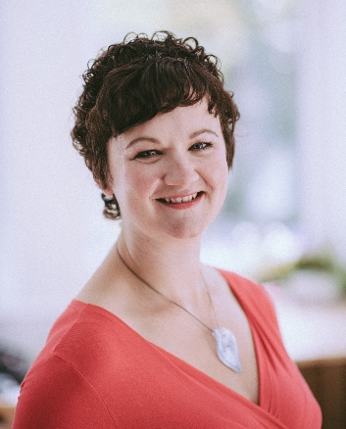
Hello Reinventors! I’m Beth. Rosie has given us incredible recipes, meal plans, and a wealth of nutritional knowledge within this fantastic Reinvent programme! It’s given us the know-how and confidence to enable us to eat well for life.
But are you struggling to stick to it? I’ll be honest; I never used to be able to maintain healthy meal plans in the long-term. When I was feeling stressed or lonely or bored …in those moments I didn’t crave salad, I reached for the junk!
If we are to fully benefit from this programme, we need to put the incredible nutritional information Reinvent has taught us into practice, and stick with it, so that it becomes a part of a life-long healthy lifestyle.
I’m here to offer a few mindset hints and tips to support anyone who is struggling to make consistently great choices, because all the decisions we make about what to eat, when to eat, and how much to eat, are made inside our very own minds.
I’ve put together 7 daily mindset hacks to support you in getting your mind on board with your health and nutrition goals.

